Ex : 01

11/12/2025 SET - 1 Program using Classes and Objects

- Create a class student with data members name and age. Write a program to create an object and display the student details.
AIM :
To create a class student with data members name and age, and to create an object to display the student details
Algorithm :
  - Start the program.
  - Define a class named student.
  - Declare data members:
    - Name (string)
    - Age (integer)
  - Create a member function to input student details.
  - Create another member function to display student details.
  - In the main function:
    - Create an object of the class student.
    - Call the input function.
    - Call the display function.
  - Stop the program.
Source Code
class Student {
String name;
int age;
void display() {
System.out.println("Name: " + name);
System.out.println("Age: " + age);
}
}
public class Main {
public static void main(String[] args) {
Student s1 = new Student();
s1.name = "Nandhu";
s1.age = 67;
s1.display();
}
}
Output :
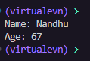
Result:
The program successfully creates a student object and displays the student details.

- Create a class rectangle with length and breadth. Write a program to compute and display the area using an object.
Aim :
To create a class named rectangle with data members length and breadth, and to compute and display the area using an object
Algorithm :
- Start the program
- Define a class rectangle
- Declare data members: length and breadth
- Create a member function to calculate area
- In the main function:
  - Create an object of class rectangle
  - Assign values to length and breadth
  - Call the function to compute area
- Display the area
- End the program

Source Code :
class Rectangle {
int length;
int breadth;

int area() {
return length * breadth;
}
}
public class Main {
public static void main(String[] args) {
Rectangle r = new Rectangle();
r.length = 10;
r.breadth = 5;
System.out.println("Area: " + r.area());
}
}
Output :
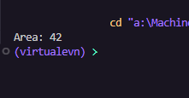

Result :
The program successfully calculates and displays the area of the rectangle using an object

- Create a class circle with radius. Write a program to compute the area and circumference using methods.

Aim
To create a class named circle with data member radius, and to compute the area
and circumference using member functions.

Algorithm
- Start the program
- Define a class circle
- Declare data member: radius
- Create member functions:
  - Area() to calculate area
  - Circumference() to calculate circumference
- In the main function:
  - Create an object of class circle
  - Assign value to radius
  - Call both methods
- Display the area and circumference
- End the program

Source Code :

class Circle {
double radius;
void setRadius(double r) {
radius = r;
}
double getArea() {
return Math.PI * radius * radius;
}
double getCircumference() {
return 2 * Math.PI * radius;
}
}
public class Main {
public static void main(String[] args) {
Circle c = new Circle();
c.setRadius(5); // example value
System.out.println("Radius: " + c.radius);
System.out.println("Area: " + c.getArea());
System.out.println("Circumference: " + c.getCircumference());
}
}
Output :

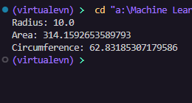

Result :
The program successfully calculates and displays the area and circumference of the
circle using methods.

- Create a class employee with name and salary. Write a program to calculate and display the yearly salary

Aim :
To create a class named employee with data members name and salary, and to calculate and display the yearly salary.
Algorithm
- Start the program
- Define a class employee
- Declare data members: name and monthly salary
- Create a member function to calculate yearly salary
- In the main function:
  - Create an object of class employee
  - Assign values to name and salary
  - Call the function to compute yearly salary
- Display the employee details and yearly salary
- End the program

Source Code :
class Employee {
String name;
double salary; // monthly salary

// Method to set details
void setDetails(String n, double s) {
name = n;
salary = s;
}

// Method to calculate yearly salary
double getYearlySalary() {
return salary * 12;
}

// Method to display details
void display() {
System.out.println("Name: " + name);
System.out.println("Monthly Salary: " + salary);
System.out.println("Yearly Salary: " + getYearlySalary());
}
}

public class Main {
public static void main(String[] args) {
Employee e = new Employee();

e.setDetails("Sharvesh", 25000); // example

e.display();
}
}
Output :
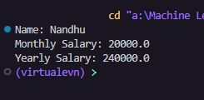
Result :
The program successfully calculates and displays the yearly salary of the employee.

- Create a class bankaccount with name and balance. Write a program to deposit an amount and display the updated balance.
Aim
To create a class named bankaccount with data members name and balance, and to deposit an amount and display the updated balance.
Algorithm
  - Start the program
  - Define a class bankaccount
  - Declare data members: name and balance
  - Create a member function deposit() to add amount to balance
  - Create a function display() to show details
  - In the main function:
- Create an object of class bankaccount
- Assign initial values
- Call deposit function with amount
  - Display updated balance
  - End the program
Source Code :
class BankAccount {
String name;
double balance;

void setDetails(String n, double b) {
name = n;
balance = b;
}

void deposit(double amount) {
balance += amount;
}

void display() {
System.out.println("Name: " + name);
System.out.println("Balance: " + balance);
}
}

public class Main {
public static void main(String[] args) {
BankAccount b = new BankAccount();
b.setDetails("Sharvesh", 1000);
b.deposit(500);
b.display();
}
}

OutPut :
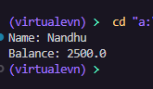
Result :
The program successfully deposits the amount and displays the updated balance.
- Create a class book with title, author, and price. Write a program to display the book details using an object.
Aim
To create a class named Book with data members title, author, and price, and to display the book details using an object.
Algorithm
- Start the program
- Define a class Book
- Declare data members: title, author, and price
- Create a member function display() to show book details
- In the main function:
  - Create an object of class Book
  - Assign values to title, author, and price
  - Call the display function
- Display the book details
- End the program
Source Code :
class Book {
String title;
String author;
double price;

void setDetails(String t, String a, double p) {
title = t;
author = a;
price = p;
}

void display() {
System.out.println("Title: " + title);
System.out.println("Author: " + author);
System.out.println("Price: " + price);
}
}

public class Main {
public static void main(String[] args) {
Book b = new Book();
b.setDetails("Java Basics", "James", 499);
b.display();
}
}
OUTPUT :
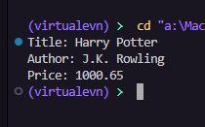
Result
The program successfully creates a Book object and displays the book details.

- Create a class marks with three subject marks. Write a program to compute total and average marks.
Aim
To create a class named Marks with three subject marks, and to compute the total and average marks.
Algorithm
- Start the program
- Define a class Marks
- Declare data members: mark1, mark2, mark3
- Create a member function to calculate total
- Create another function to calculate average
- In the main function:
  - Create an object of class Marks
  - Assign values to marks
  - Call functions to compute total and average
- Display the total and average
- End the program
Source Code :
class Marks {
int m1, m2, m3;

void setMarks(int a, int b, int c) {
m1 = a;
m2 = b;
m3 = c;
}

int getTotal() {
return m1 + m2 + m3;
}

double getAverage() {
return getTotal() / 3.0;
}

void display() {
System.out.println("Total: " + getTotal());
System.out.println("Average: " + getAverage());
}
}

public class Main {
public static void main(String[] args) {
Marks m = new Marks();
m.setMarks(80, 75, 90);
m.display();
}
}
Output :
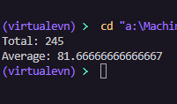
Result
The program successfully calculates and displays the total and average marks
Ex : 02

11/12/2025 SET - 2 OOP Methods and String Handling

- Create class Number with only one private instance variable as a double primitive type. To include the following methods isZero( ), isPositive(), isNegative( ), isOdd( ), isEven( ), isPrime(), isAmstrong() the above methods return boolean primitive type. getFactorial(), getSqrt(), getSqr(), sumDigits(), getReverse() the above methods return double primitive type.
Aim :
To create a class Number with a private double variable and implement methods to check number properties and perform mathematical operations.

Algorithm
  - Start the program
  - Define a class Number
  - Declare a private double variable
  - Create a constructor to initialize the number
  - Implement boolean methods:
    - isZero(), isPositive(), isNegative()
    - isOdd(), isEven()
    - isPrime(), isArmstrong()
  - Implement double methods:
    - getFactorial(), getSqrt(), getSqr()
    - sumDigits(), getReverse()
  - In main():
    - Create object and pass value
    - Call all methods
  - Display results
  - End the program
Source Code :
class Number {
private double num;
Number(double n) {
num = n;
}
boolean isZero() {
return num == 0;
}
boolean isPositive() {
return num > 0;
}

boolean isNegative() {
return num < 0;
}
boolean isEven() {
if (num % 1 != 0) return false;
return ((long) num) % 2 == 0;
}
boolean isOdd() {
if (num % 1 != 0) return false;
return ((long) num) % 2 != 0;
}
boolean isPrime() {
if (num % 1 != 0 || num <= 1) return false;
long n = (long) num;
for (long i = 2; i <= Math.sqrt(n); i++) {
if (n % i == 0) return false;
}
return true;
}
boolean isAmstrong() {
if (num % 1 != 0 || num < 0) return false;
long n = (long) num;
long temp = n, sum = 0;
int digits = String.valueOf(n).length();
while (temp > 0) {
long d = temp % 10;
sum += Math.pow(d, digits);
temp /= 10;
}
return sum == n;
}
double getFactorial() {
if (num % 1 != 0 || num < 0) return -1;
long n = (long) num;
double fact = 1;
for (int i = 1; i <= n; i++) fact *= i;
return fact;
}
double getSqrt() {
return Math.sqrt(num);
}
double getSqr() {
return num * num;
}
double sumDigits() {
long n = (long) Math.abs(num);
double sum = 0;
while (n > 0) {
sum += n % 10;
n /= 10;
}
return sum;
}
double getReverse() {
long n = (long) Math.abs(num);
long rev = 0;
while (n > 0) {
rev = rev * 10 + (n % 10);
n /= 10;
}
return rev;
}
}
public class Main {
public static void main(String[] args) {
Number n = new Number(153);
System.out.println("isZero: " + n.isZero());
System.out.println("isPositive: " + n.isPositive());
System.out.println("isNegative: " + n.isNegative());
System.out.println("isEven: " + n.isEven());
System.out.println("isOdd: " + n.isOdd());
System.out.println("isPrime: " + n.isPrime());
System.out.println("isAmstrong: " + n.isAmstrong());
System.out.println("Factorial: " + n.getFactorial());
System.out.println("Square Root: " + n.getSqrt());
System.out.println("Square: " + n.getSqr());
System.out.println("Sum of Digits: " + n.sumDigits());
System.out.println("Reverse: " + n.getReverse());
}
}
Output :
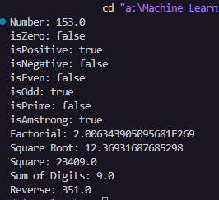
Result
The program successfully checks number properties and performs mathematical
operations using the Number class.
- Write a Java program that prints all real solutions to the quadratic equation ax² + bx + c = 0. Create a class Quad, read in a, b, c and use the quadratic formula. If the discriminant (b²–4ac) is negative; display a message stating that there are no real solutions

Aim
To write a Java program using a class Quad to find all real solutions of a quadratic equation
² + + = 0using the quadratic formula.
Algorithm
  - Start the program
  - Create a class Quad
  - Declare variables a, b, c
  - Read values of a, b, c from user
  - Calculate discriminant: = ² − 4
  - If D < 0, display "No real solutions"
  - Else compute roots using formula: = − ±

2

  - Display the roots
  - End the program
Source code :
import java.util.Scanner;
class Quad {
double a, b, c;
void read() {
Scanner sc = new Scanner(System.in);
a = sc.nextDouble();
b = sc.nextDouble();
c = sc.nextDouble();
}
void solve() {
double d = b * b - 4 * a * c;
if (d < 0) {
System.out.println("No real solutions");
} else {
double r1 = (-b + Math.sqrt(d)) / (2 * a);
double r2 = (-b - Math.sqrt(d)) / (2 * a);
System.out.println("Roots: " + r1 + " , " + r2);
}
}
}
public class Main {
public static void main(String[] args) {
Quad q = new Quad();
q.read();
q.solve();
}
}

Output :
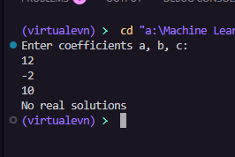
Result
The program successfully calculates and displays the real roots of the quadratic equation or shows a message if no real solutions exist.

- Explore String, StringBuffer and StringBuilder classes in Java. Create a java program that utilizes any five built-in functions in each of the above mentioned classes.

Aim
To explore String, StringBuffer, and StringBuilder classes in Java by using at least five built-in functions from each class.
Algorithm
  - Start the program
  - Create a String object and apply 5 built-in methods
  - Create a StringBuffer object and apply 5 built-in methods
  - Create a StringBuilder object and apply 5 built-in methods
  - Display results of all operations
  - End the program
Source Code :
class Demo {
public static void main(String[] args) {

String s = "Hello World";
System.out.println(s.length());
System.out.println(s.toUpperCase());
System.out.println(s.substring(0, 5));
System.out.println(s.replace("World", "Java"));
System.out.println(s.contains("Hello"));

StringBuffer sb = new StringBuffer("Hello");
sb.append(" World");
System.out.println(sb);
sb.insert(5, " Java");
System.out.println(sb);
sb.replace(0, 5, "Hi");
System.out.println(sb);
sb.delete(2, 6);
System.out.println(sb);
System.out.println(sb.reverse());

StringBuilder sbd = new StringBuilder("Hello");
sbd.append(" World");
System.out.println(sbd);
sbd.insert(5, " Java");
System.out.println(sbd);
sbd.replace(0, 5, "Hi");
System.out.println(sbd);
sbd.delete(2, 6);
System.out.println(sbd);
System.out.println(sbd.reverse());
}
}
Output :
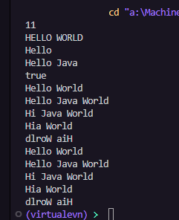
Result
The program successfully demonstrates the use of five built-in methods each from:
- String (immutable)
- StringBuffer (mutable, thread-safe)
- StringBuilder (mutable, not thread-safe but faster)

- Write a program to count frequency of a given letter in a String

Aim
To write a Java program to count the frequency of a given letter in a string.
Algorithm
  - Start the program
  - Declare a string
  - Read a character to be searched
  - Initialize a counter to 0
  - Traverse each character of the string
  - Compare each character with the given letter
  - If matched, increment the counter
  - Display the frequency
  - End the program
Source Code :

import java.util.Scanner;
class Main {
public static void main(String[] args) {
Scanner sc = new Scanner(System.in);
String str = sc.nextLine();
char ch = sc.next().charAt(0);
int count = 0;
for (int i = 0; i < str.length(); i++) {
if (str.charAt(i) == ch) {
count++;
}
}
System.out.println("Frequency: " + count);
}
}
Output :
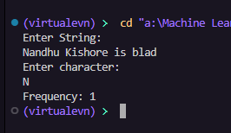

Result
The program successfully counts and displays the frequency of the given character in the string.
- Write a Java program to find the number of characters, words, lines in a given input file.
Aim
To write a Java program to count the number of characters, words, and lines in a given input file.
Algorithm
  - Start the program
  - Open the file using file handling classes
  - Initialize counters:
    - charCount = 0
    - wordCount = 0
    - lineCount = 0
  - Read the file line by line
  - For each line:
    - Increment line count
    - Count characters in the line
    - Split the line into words and count them
  - Display the counts
  - Close the file
  - End the program Source code
import java.io.BufferedReader;
import java.io.FileReader;
import java.io.IOException;
public class Main {
public static void main(String[] args) throws IOException {
BufferedReader br = new BufferedReader(new FileReader("input.txt"));
int characters = 0, words = 0, lines = 0;
String line;
while ((line = br.readLine()) != null) {
lines++;
characters += line.length();
String[] w = line.trim().split("\\s+");
if (line.trim().length() != 0)
words += w.length;
}
br.close();
System.out.println("Characters: " + characters);
System.out.println("Words: " + words);
System.out.println("Lines: " + lines);
}
}

Output
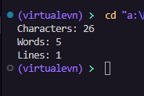

Reuslt :
The program successfully reads the file and displays the number of characters , words , and lines

- Write a Java program to find the length of the longest word of a given sentence without repeating characters.

Aim
To write a Java program to find the length of the longest word in a given sentence such that the word has no repeating characters.
Algorithm
  - Start the program
  - Read a sentence from the user
  - Split the sentence into words
  - For each word:
    - Check if it has repeating characters
    - If no repetition, find its length
  - Compare lengths and store the maximum
  - Display the length of the longest valid word
  - End the program
Source code
import java.io.*;
import java.util.Scanner; class Unistring
{
static String line;
static boolean rep(String w)
{
int f[]=new int[256];
for(int k=0;k<w.length();k++)
{
char ch = w.charAt(k); if (f[ch] == 1) {
return false;
}
f[ch]++;
}
return true;
}
static int uni_len(String w[] )
{
int max_len=0,newlen=0; int len=w.length;
for(int i=0;i<len;i++)
{
if(rep(w[i]))
{
newlen=w[i].length(); max_len=Math.max(max_len,newlen);
}
}return max_len;
}
public static void main(String[] args)
{
Scanner sc=new Scanner(System.in); System.out.println("enter the line: "); line=sc.nextLine();
line = line.toLowerCase(); System.out.println("entered the line: "+line); String word[]=line.split(" ");
int len=word.length;
System.out.println("max length of the string with unique letters :"+uni_len(word));
} }
Output
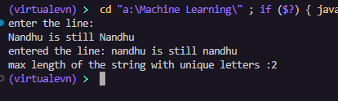
Result
The program successfully finds the longest word with no repeating characters and displays its length
Ex : 03

19/12/2025 SET - 3 Using Access Specifiers, Constructors, Arrays, and Searching Techniques

- . Write a java code to find the distance from Ranchi to major cities of India.
Aim
To write a Java program to find the distance from Ranchi to major cities of India using binary search.
Algorithm
  - Start the program
  - Create a String array of city names (sorted)
  - Create an integer array of corresponding distances
  - Read the city name from the user
  - Use binary search to find the city index
  - If found, display the distance
  - Else display "City not found"
  - End the program
Source Code
import java.util.Scanner;
class Ranchi {
static int findDist(int p, int[] pnum, int[] dist) {
for (int i = 0; i < pnum.length; i++) {
if (pnum[i] == p) {
return dist[i];
}
}
return -1;
}
public static void main(String[] args) {
int[] pnum = {1,2,3,4,5,6,7,8,9};
String[] places = {"Khunti","Patratu","Hazaribagh","Bokaro","Jamshedpur","Dhanbad","Medininagar","Deoghar","Patna"};
int[] dist = {40,36,95,120,125,150,170,190,300};

Scanner s = new Scanner(System.in);
System.out.println("Enter the place number (1-9)");
int p = s.nextInt();
int d = findDist(p, pnum, dist);
if (d != -1)
System.out.println("Distance between " + places[p-1] + " and Ranchi is " + d);
else
System.out.println("Invalid input");
s.close();
}
}
Output
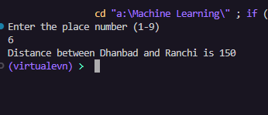
Result
The program successfully searches for the given city using binary search and displays the distance from Ranchi

Travel Booking – Calculate Ticket Fare Based on Passenger Type Method calculateFare() is overloaded for:
- Adult
- Child
- Senior Citizen
Aim
To write a Java program for Travel Booking that calculates ticket fare using method overloading based on passenger type: Adult, Child, and Senior Citizen.
Algorithm
- Start the program
- Create a class TravelBooking
- Define overloaded methods calculateFare() for:
  - Adult
  - Child (with discount)
  - Senior Citizen (with higher discount)
- In the main method:
  - Call respective methods
- Display calculated fare
- End the program
Source Code
import java.util.Scanner;
class TravelBooking {
double calculateFare(double baseFare) {
return baseFare;
}
double calculateFare(double baseFare, int age) {
if (age < 12)
return baseFare * 0.5;
else if (age >= 60)
return baseFare * 0.7;
else
return baseFare;
}
}
public class Main {
public static void main(String[] args) {
Scanner sc = new Scanner(System.in);
TravelBooking t = new TravelBooking();

System.out.print("Enter base fare: ");
double baseFare = sc.nextDouble();

System.out.print("Enter age: ");
int age = sc.nextInt();
double fare = t.calculateFare(baseFare, age);

System.out.println("Ticket Fare: " + fare);

sc.close();
}
}
Output :
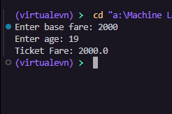
Result
The program successfully calculates ticket fare using method overloading for different passenger types.

Grocery Bill Generator
Constructor sets item name & price. Method overloading to calculate total price:
- With quantity
- With quantity + discount
Aim
To write a Java program for a Grocery Bill Generator using a constructor and method overloading to calculate total price:
  - With quantity
  - With quantity and discount Algorithm
- Start the program
- Create a class Grocery
- Declare data members: itemName and price
- Create a constructor to initialize values
- Define overloaded methods:
  - calculateTotal(int quantity)
  - calculateTotal(int quantity, double discount)
- In main():
  - Create object using constructor
  - Call both methods
- Display total bill
- End the program
Source Code :
import java.util.Scanner;
class Grocery {
String item;
double price;
Grocery(String item, double price) {
this.item = item;
this.price = price;
}
double total(int quantity) {
return price * quantity;
}
double total(int quantity, double discount) {
double total = price * quantity;
return total - (total * discount / 100);
}
}
public class Main {
public static void main(String[] args) {
Scanner sc = new Scanner(System.in);
System.out.print("Enter item name: ");
String item = sc.nextLine();
System.out.print("Enter price: ");
double price = sc.nextDouble();
Grocery g = new Grocery(item, price);
System.out.print("Enter quantity: ");
int quantity = sc.nextInt();
System.out.print("Apply discount? (yes=1 / no=0): ");
int choice = sc.nextInt();
if (choice == 1) {
System.out.print("Enter discount %: ");
double discount = sc.nextDouble();
System.out.println("Total Price: " + g.total(quantity, discount));
} else {
System.out.println("Total Price: " + g.total(quantity));
}
sc.close();
}
}
Output :
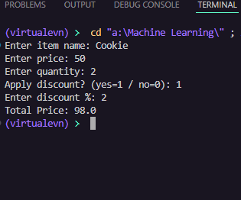
Result
The program successfully generates the grocery bill using constructor initialization
and method overloading.

Ex : 04
19/12/2025
SET-4 Inheritance and Polymorphism
- Write OOPs based Java program to perform the arithmetic addition operation using the concept of method overloading.
Aim
To write a Java program using OOP concept (Method Overloading) to perform arithmetic addition with different parameter types.
Algorithm
  - Start the program
  - Create a class Addition
  - Define overloaded methods add():
    - Add two integers
    - Add three integers
    - Add one integer and one float
  - Each method returns the result
  - In the main method:
    - Create object of class
    - Call all overloaded methods
  - Display the results
  - End the program

Source Code:
import java.util.Scanner;
class Addition {
int add(int a, int b) {
return a + b;
}
double add(double a, double b) {
return a + b;
}
int add(int a, int b, int c) {
return a + b + c;
}
}
public class Main {
public static void main(String[] args) {
Scanner sc = new Scanner(System.in);
Addition obj = new Addition();

System.out.print("Enter two integers: ");
int a = sc.nextInt();
int b = sc.nextInt();
System.out.println("Sum (int): " + obj.add(a, b));
System.out.print("Enter two doubles: ");
double x = sc.nextDouble();
double y = sc.nextDouble();
System.out.println("Sum (double): " + obj.add(x, y));
System.out.print("Enter three integers: ");
int p = sc.nextInt();
int q = sc.nextInt();
int r = sc.nextInt();
System.out.println("Sum (3 ints): " + obj.add(p, q, r));
sc.close();
}
}
Output :
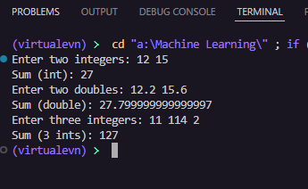

Result
The program successfully performs addition using method overloading and returns
results to the calling statements

- Using the scenario of the Jio–Hotstar streaming platform, write a Java program to demonstrate simple inheritance. Create a base class Hotstar with a method to display the platform name. Derive a class Genre from Hotstar that contains details such as genre name and subscription type. Create an object of the Genre class and use it to access both the inherited method and the genre-specific details.
Aim
To demonstrate simple inheritance in Java using the Jio–Hotstar streaming platform scenario.
Algorithm
  - Start the program
  - Create a base class Hotstar
  - Define a method to display platform name
  - Create a derived class Genre that extends Hotstar
  - Declare data members: genreName and subscriptionType
  - Create a method to display genre details
  - In the main method:
    - Create an object of Genre
    - Call inherited method and derived class method
  - Display all details
  - End the program
Source Code :
import java.util.Scanner;
class Hotstar {
void displayPlatform() {
System.out.println("Platform: Jio Hotstar");
}
}
class Genre extends Hotstar {
String genreName;
String subscriptionType;
void setDetails(String genreName, String subscriptionType) {
this.genreName = genreName;
this.subscriptionType = subscriptionType;
}
void displayDetails() {
System.out.println("Genre: " + genreName);
System.out.println("Subscription: " + subscriptionType);
}
}
public class Main {
public static void main(String[] args) {
Scanner sc = new Scanner(System.in);
Genre g = new Genre();
System.out.print("Enter genre: ");
String genre = sc.nextLine();
System.out.print("Enter subscription type: ");
String sub = sc.nextLine();
g.setDetails(genre, sub);
g.displayPlatform();
g.displayDetails();

sc.close();
}
}
Output :
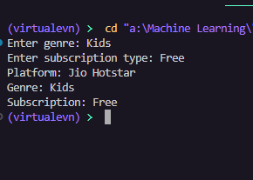
Result
The program successfully demonstrates simple inheritance, where the derived class Genre accesses both:
- Base class method (displayPlatform())
- Its own methods (displayDetails())

- Write a Java program to demonstrate the concept of method overriding using dynamic method dispatch for calculating Simple Interest of three banks. Create a base class named Bank that contains a method to calculate simple interest. Derive three classes BankA, BankB, and BankC from the Bank class and override the interest calculation method in each derived class with their respective rates of interest as follows: Bank A – 10%, Bank B – 9%, and Bank C – 7%. Create a reference of the base class Bank and use it to invoke the overridden methods of the derived classes, thereby demonstrating dynamic method dispatch.
Aim
To demonstrate method overriding and dynamic method dispatch in Java by calculating Simple Interest for different banks.
Algorithm (Simple Steps)
- Start the program
- Create a base class Bank with method calculateSI()
- Create derived classes BankA, BankB, BankC extending Bank
- Override calculateSI() in each class with different interest rates:
  - BankA → 10%
  - BankB → 9%
  - BankC → 7%
- In main():
  - Create a reference of base class Bank
  - Assign objects of derived classes
  - Call overridden method using base reference
- Display simple interest for each bank
- End the program
Source Code :
import java.util.Scanner;
class Bank {
double calculateSI(double p, double t) {
return 0;
}
}
class BankA extends Bank {
double calculateSI(double p, double t) {
return (p * t * 10) / 100;
}
}
class BankB extends Bank {
double calculateSI(double p, double t) {
return (p * t * 9) / 100;
}
}
class BankC extends Bank {
double calculateSI(double p, double t) {
return (p * t * 7) / 100;
}
}
public class Main {
public static void main(String[] args) {
Scanner sc = new Scanner(System.in);
System.out.print("Enter principal: ");
double p = sc.nextDouble();
System.out.print("Enter time: ");
double t = sc.nextDouble();
Bank b;
b = new BankA();
System.out.println("Simple Interest (Bank A): " + b.calculateSI(p, t));

b = new BankB();
System.out.println("Simple Interest (Bank B): " + b.calculateSI(p, t));
b = new BankC();
System.out.println("Simple Interest (Bank C): " + b.calculateSI(p, t));
sc.close();
}
}
Output :
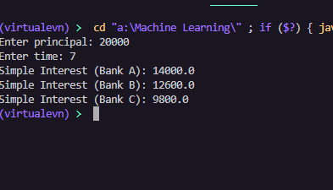
Result
The program successfully demonstrates:
- Method Overriding (same method redefined in subclasses)
- Dynamic Method Dispatch (method call decided at runtime)

Ex : 05

22/01/2025 SET - 5 Class Diagram and Sequence Diagram

- What is a class diagram? List its Components and visibility symbols. Draw the class diagram for your chosen entity with appropriate name, attributes and operations (class name, private data members and public methods).
What is a Class Diagram?
A Class Diagram is a type of UML (Unified Modeling Language) diagram that represents the structure of a system by showing its classes, attributes, methods, and the relationships among objects.
It is mainly used in object-oriented design to model real-world systems and software structure.
Components of a Class Diagram
  - Class Name
    - Represents the name of the class.
    - Written at the top section.
  - Attributes (Data Members)
    - Variables that store data.
    - Written in the middle section.
  - Operations (Methods/Functions)
    - Functions that define behavior.
    - Written in the bottom section.
  - Relationships (optional)
    - Association, Inheritance, Aggregation, Composition, etc. Visibility Symbols
Symbol Meaning
+ Public
- Private
# Protected
~ Default
Example Class Diagram (Student Class)
Class: Student

| Student |

| - rollNo : int |
| - name : String |
| - marks : float |

| + setData() |
| + displayData() |
| + calculateGrade() |

Explanation
- Class Name: Student
- Private Data Members (-):
  - rollNo
  - name
  - marks
- Public Methods (+):
  - setData() → Assign values
  - displayData() → Show details
  - calculateGrade() → Compute grade

- Explain different relationships between the classes (association, aggregation, composition, and generalization) with example diagrams.
Relationships Between Classes in UML
In a class diagram, relationships define how classes are connected and interact with each other.
- Association Definition
Association represents a general relationship between two classes where objects are connected.
Example
A Teacher teaches Students Diagram
+-----------+ teaches + +
| Teacher | --------------------> | Student |
+-----------+ + +
Key Points
- Simple connection between classes
- Can be one-to-one, one-to-many, many-to-many
- Aggregation (HAS-A, Weak Relationship) Definition
Aggregation represents a "whole-part" relationship where the part can exist independently of the whole.
Example
A Department has Teachers, but teachers can exist without a department. Diagram
+ + ◇ + +
| Department |--------------------| Teacher |
+ + + +
(◇= Hollow diamond)
Key Points
- Weak ownership
- Part can exist independently
- Composition (Strong HAS-A Relationship) Definition
Composition is a strong form of aggregation where the part cannot exist independently of the whole.
Example
A House has Rooms, rooms cannot exist without the house. Diagram

+ + ◆ + +
| House |---------------------| Room |
+--------+ + +
(◆= Filled diamond)
Key Points
- Strong ownership
- Part is destroyed when whole is destroyed

- Generalization (IS-A Relationship / Inheritance) Definition
Generalization represents inheritance, where one class derives from another. Example
A Car is a Vehicle Diagram
+ +
| Vehicle |
+ +
▲
|
+ +
| Car |
+ +
(▲ = Inheritance arrow)
Key Points
Child inherits properties of parent
- Draw the class diagram for the previous Jio-Hotstart program scenario. 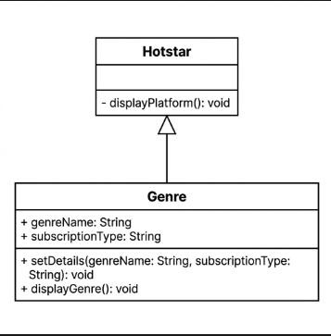
Ex : 06

22/01/2025 SET - 6 Polymorphism , Abstract Class and Interface

- A transport company is developing a Vehicle Rental System where different types of vehicles calculate rental charges differently. All vehicles share common properties like vehicleNumber and ratePerDay, but the charge calculation varies for Car, Bike, and Truck. Design an abstract class named Vehicle with an abstract method calculateRent(int days). Implement subclasses for each vehicle type and demonstrate how abstraction helps in hiding implementation details while allowing flexibility in rental calculation.
Aim
To design a Vehicle Rental System using abstraction in Java, where different vehicles calculate rent differently using an abstract class.
Algorithm
- Start the program
- Create an abstract class Vehicle
- Declare data members: vehicleNumber and ratePerDay
- Define an abstract method calculateRent(int days)
- Create subclasses: Car, Bike, Truck extending Vehicle
- Override calculateRent() in each subclass with specific logic
- In main():
  - Create objects of each vehicle type
  - Call calculateRent()
- Display rental charges
- End the program
Source Code :
import java.util.Scanner;
abstract class Vehicle {
String vehicleNumber;
double ratePerDay;
Vehicle(String vehicleNumber, double ratePerDay) {
this.vehicleNumber = vehicleNumber;
this.ratePerDay = ratePerDay;
}
abstract double calculateRent(int days);
}
class Car extends Vehicle {
Car(String vehicleNumber, double ratePerDay) {
super(vehicleNumber, ratePerDay);
}
double calculateRent(int days) {
return ratePerDay * days;
}
}
class Bike extends Vehicle {
Bike(String vehicleNumber, double ratePerDay) {
super(vehicleNumber, ratePerDay);
}
double calculateRent(int days) {
return ratePerDay * days * 0.9;
}
}
class Truck extends Vehicle {
Truck(String vehicleNumber, double ratePerDay) {
super(vehicleNumber, ratePerDay);
}
double calculateRent(int days) {
return ratePerDay * days * 1.2;
}
}
public class Main {
public static void main(String[] args) {
Scanner sc = new Scanner(System.in);

System.out.print("Enter vehicle type (car/bike/truck): ");
String type = sc.next();

System.out.print("Enter vehicle number: ");
String number = sc.next();

System.out.print("Enter rate per day: ");
double rate = sc.nextDouble();

System.out.print("Enter number of days: ");
int days = sc.nextInt();

Vehicle v;

if (type.equalsIgnoreCase("car")) {
v = new Car(number, rate);
} else if (type.equalsIgnoreCase("bike")) {
v = new Bike(number, rate);
} else {
v = new Truck(number, rate);
}
System.out.println("Total Rent: " + v.calculateRent(days));
sc.close();
}
}

Output :
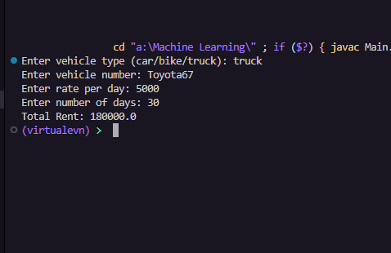

Result
The program successfully demonstrates abstraction where:
- Common properties are defined in abstract class
- Different rent calculations are implemented in subclasses

- A company is creating an Online Shopping Application in Java. All products have common features such as productId, productName, and price, but the discount calculation differs for Electronics, Clothing, and Grocery items. Design an abstract class called Product with an abstract method calculateDiscount(). Implement the subclasses and write a Java program that uses the abstract class reference to calculate the final price of different products.
Aim
To design an Online Shopping Application using abstraction in Java, where different products calculate discounts differently.
Algorithm
- Start the program
- Create an abstract class Product
- Declare data members: productId, productName, price
- Define an abstract method calculateDiscount()
- Create subclasses:
  - Electronics
  - Clothing
  - Grocery
- Use Product reference to call subclass methods
- Display final price after discount
- End the program
Source Code
import java.util.Scanner;
abstract class Product {
int productId;
String productName;
double price;
Product(int productId, String productName, double price) {
this.productId = productId;
this.productName = productName;
this.price = price;
}
abstract double calculateDiscount();
}
class Electronics extends Product {
Electronics(int id, String name, double price) {
super(id, name, price);
}
double calculateDiscount() {
return price * 0.10;
}
}
class Clothing extends Product {
Clothing(int id, String name, double price) {
super(id, name, price);
}
double calculateDiscount() {
return price * 0.20;
}
}
class Grocery extends Product {
Grocery(int id, String name, double price) {
super(id, name, price);
}
double calculateDiscount() {
return price * 0.05;
}
}
public class Main {
public static void main(String[] args) {
Scanner sc = new Scanner(System.in);
System.out.print("Enter product type (electronics/clothing/grocery): ");
String type = sc.next();
System.out.print("Enter product id: ");
int id = sc.nextInt();
System.out.print("Enter product name: ");
String name = sc.next();
System.out.print("Enter price: ");
double price = sc.nextDouble();
Product p;
if (type.equalsIgnoreCase("electronics"))
p = new Electronics(id, name, price);
else if (type.equalsIgnoreCase("clothing"))
p = new Clothing(id, name, price);
else
p = new Grocery(id, name, price);
double discount = p.calculateDiscount();
double finalPrice = price - discount;
System.out.println("Final Price: " + finalPrice);
sc.close();
}
}
Output :
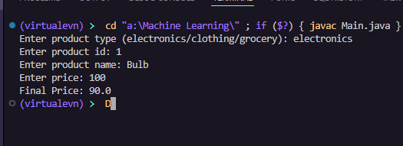
Result
The program successfully demonstrates abstraction where:
- Common features are defined in the Product class
- Discount calculation varies in subclasses

Ex : 07

30/01/2025 SET - 7 Employee Payroll Management System Using Inheritance in Java

A company wants to develop a Payroll Management System using Java by applying inheritance and object-oriented concepts.
Aim
To develop a Payroll Management System using Java by applying inheritance, this, super, and final keyword concepts.
Algorithm
- Start the program
- Create base class Department
  - Declare deptId and deptName
  - Use constructor with this keyword
- Create subclass EmployeePayroll extending Department
  - Declare empId, empName, basicSalary
  - Declare final companyName
  - Use super to call base class constructor
  - Use this to assign values
- Create a method to display details
- In main():
  - Create an array of EmployeePayroll objects
  - Store multiple employee details
  - Display all details
  - End the program
Source code
import java.util.Scanner;
class Department {
int deptId;
String deptName;
Department(int deptId, String deptName) {
this.deptId = deptId;
this.deptName = deptName;
}
}
class EmployeePayroll extends Department {
int empId;
String empName;
double basicSalary;
final String companyName = "ABC Company";
EmployeePayroll(int deptId, String deptName, int empId, String empName, double basicSalary) {
super(deptId, deptName);
this.empId = empId;
this.empName = empName;
this.basicSalary = basicSalary;
}
void display() {
System.out.println(companyName + " | DeptID: " + deptId + " | DeptName: " + deptName + " | EmpID: " + empId + " | EmpName: " + empName + " | Salary: " + basicSalary);
}
}
public class Main {
public static void main(String[] args) {
Scanner sc = new Scanner(System.in);
System.out.print("Enter number of employees: ");
int n = sc.nextInt();
EmployeePayroll[] emp = new EmployeePayroll[n];
for (int i = 0; i < n; i++) {
System.out.print("Enter Dept ID: ");
int dId = sc.nextInt();
System.out.print("Enter Dept Name: ");
String dName = sc.next();
System.out.print("Enter Emp ID: ");
int eId = sc.nextInt();
System.out.print("Enter Emp Name: ");
String eName = sc.next();
System.out.print("Enter Basic Salary: ");
double sal = sc.nextDouble();
emp[i] = new EmployeePayroll(dId, dName, eId, eName, sal);
}
for (int i = 0; i < n; i++) {
emp[i].display();
}
sc.close();
}
}

Output :
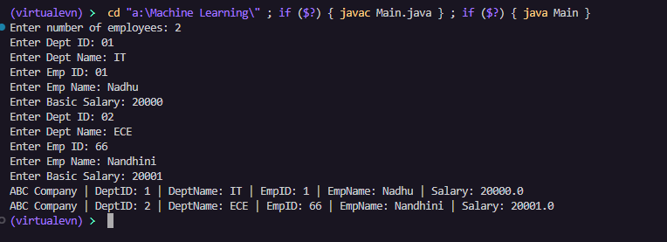

Result
The program demonstrates Inheritance (EmployeePayroll inherits Department), use of this keyword (to distinguish variables), use of super keyword (to call base class constructor), use of final keyword (for constant company name), and handling multiple objects using an array.

Ex : 08

19/02/2025 SET - 8 Using Exceptions

- Write a Java program to calculate the total electricity bill of a household.
The program must first read the number of months n for which electricity units are entered. Input should be taken from the keyboard at runtime.
  - If n is zero or negative, throw a suitable user-defined exception.
  - If the input for n cannot be converted into an integer, a NumberFormatException must be handled.
  - After reading n successfully, read the electricity units consumed for each month into an array.
  - Each input must be converted from string to integer using proper exception handling.
  - If any unit value is negative, throw a user-defined exception.
  - Finally, compute and display the total and average electricity consumption.

Use appropriate try-catch blocks and display meaningful error messages. Aim
To write a Java program to calculate the total and average electricity consumption using exception handling and user-defined exceptions.
Algorithm
- Start the program
- Read number of months n as String
- Convert it to integer using Integer.parseInt()
- If n ≤ 0, throw user-defined exception
- Handle NumberFormatException if input is invalid
- Create an array of size n
- For each month:
  - Read units as String
  - Convert to integer
  - If units < 0, throw user-defined exception
- Calculate total and average

- Display results
- End the program

Sorce Code
import java.util.Scanner;
class InvalidConsumptionException extends Exception {
InvalidConsumptionException(String msg) {
super(msg);
}
}
public class Main {
public static void main(String[] args) {
Scanner sc = new Scanner(System.in);
try {
System.out.print("Enter number of readings: ");
int n = sc.nextInt();
if (n <= 0) throw new InvalidConsumptionException("Invalid number");
double total = 0;
for (int i = 0; i < n; i++) {
System.out.print("Enter consumption: ");
double c = sc.nextDouble();
if (c < 0) throw new InvalidConsumptionException("Negative value");
total += c;
}
double avg = total / n;
System.out.println("Total: " + total);
System.out.println("Average: " + avg);
} catch (InvalidConsumptionException e) {
System.out.println(e.getMessage());
}
sc.close();
}
}
OutPut :
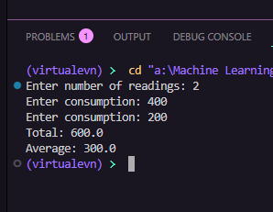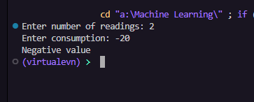

Result :
The program is executed successfully using user defined exceptions

- Write a Java program to read employee details and validate them using exception handling.
Create an Employee class with name and age as attributes. The program must:
- Throw a user-defined checked exception InvalidNameException if the employee name contains only numeric values.
- Throw a user-defined checked exception InvalidAgeException if the employee age is greater than 50.
- Handle possible runtime exceptions (such as invalid input type) using appropriate built-in exceptions.
- Use try, catch, throw, throws, and finally blocks effectively.
- If all inputs are valid, create and display the employee object.
- Display meaningful error messages for all exceptions.
Aim
To write a Java program to read and validate employee details using exception handling and user-defined exceptions.

Source Code
import java.util.Scanner;
class InvalidNameException extends Exception {
InvalidNameException(String msg) {
super(msg);
}
}
class InvalidAgeException extends Exception {
InvalidAgeException(String msg) {
super(msg);
}
}
class Employee {
String name;
int age;
Employee(String name, int age) {
this.name = name;
this.age = age;
}
void display() {
System.out.println("Name: " + name + " Age: " + age);
}
}
public class Main {
static void validate(String name, int age) throws InvalidNameException, InvalidAgeException {
if (name.matches("\\d+")) throw new InvalidNameException("Name cannot be numeric");
if (age > 50) throw new InvalidAgeException("Age cannot be greater than 50");
}
public static void main(String[] args) {
Scanner sc = new Scanner(System.in);
try {
System.out.print("Enter name: ");
String name = sc.next();
System.out.print("Enter age: ");
int age = sc.nextInt();
validate(name, age);
Employee e = new Employee(name, age);
e.display();
} catch (InvalidNameException | InvalidAgeException e) {
System.out.println(e.getMessage());
} catch (Exception e) {
System.out.println("Invalid input type");
} finally {
System.out.println("Execution completed");
sc.close();
}
}
}
Output :
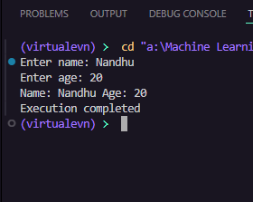
Result
The program successfully validates employee name and age, uses user-defined checked exceptions, handles runtime errors like invalid input, and displays appropriate error messages.

Ex : 09

26/02/2025 SET - 9 Threads

- Design a thread-safe implementation of Queue class. Write a multi-threaded producer- consumer application that uses this Queue class.
Aim
To design a thread-safe Queue and implement a Producer-Consumer problem using multi-threading in Java.
Algorithm
  - Start the program
  - Create a class Queue
    - Use an array to store elements
    - Use synchronized methods for thread safety
    - Use wait() and notify() for coordination
  - Create Producer thread
    - Adds elements to queue
  - Create Consumer thread
    - Removes elements from queue
  - In main():
    - Create shared Queue object
    - Start Producer and Consumer threads
  - Display produced and consumed items
  - End the program
Source Code
class Queue {
private int item;
private boolean hasValue = false;
synchronized void put(int value) {
try {
while (hasValue) wait();
item = value;
hasValue = true;
System.out.println("Produced: " + item);
notify();
} catch (Exception e) {}
}
synchronized int get() {
try {
while (!hasValue) wait();
hasValue = false;
System.out.println("Consumed: " + item);
notify();
} catch (Exception e) {}
return item;
}
}
class Producer extends Thread {
Queue q;
Producer(Queue q) {
this.q = q;
}
public void run() {
int i = 1;
while (true) {
q.put(i++);
try { sleep(500); } catch (Exception e) {}
}
}
}
class Consumer extends Thread {
Queue q;
Consumer(Queue q) {
this.q = q;
}
public void run() {
while (true) {
q.get();
try { sleep(800); } catch (Exception e) {}
}
}
}
public class Main {
public static void main(String[] args) {
Queue q = new Queue();
new Producer(q).start();
new Consumer(q).start();
}
}
Output
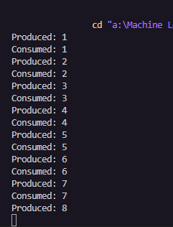

Result
The program successfully demonstrates:
- Thread-safe Queue using synchronized methods
- Producer-Consumer problem using wait() and notify()
- Proper synchronization between threads

- Write a program to display string using thread. Write a prgram to display Frame .The Frame should be titled as “JAVA” & the background Color should be set to yellow, display string at pixel location (50, 50) on a Frame
Aim
To write a Java program to display a string using a thread.
Algorithm
  - Start the program
  - Import required packages (java.awt, java.lang)
  - Create a class that extends Frame and implements Runnable
  - Declare a Thread object
  - In the constructor:
    - Set background color to yellow
    - Make the frame visible
    - Create a thread object and start it
  - Override the paint(Graphics g) method:
    - Display the string using drawString() at position (50, 50)
  - In the main method:
    - Create an object of the class
  - The thread continuously updates the frame and displays the string
  - End the program

Source code
import java.awt.*;
import java.awt.event.*;
class MyFrame extends Frame implements Runnable {
String msg = "Hello from Thread";
MyFrame() {
setTitle("JAVA");
setSize(400, 300);
setBackground(Color.YELLOW);
setVisible(true);
new Thread(this).start();
addWindowListener(new WindowAdapter() {
public void windowClosing(WindowEvent e) {
dispose();
}
});
}
public void run() {
while (true) {
repaint();
try { Thread.sleep(500); } catch (Exception e) {}
}
}
public void paint(Graphics g) {
g.drawString(msg, 50, 50);
}
}
public class Main {
public static void main(String[] args) {
new MyFrame();
}
}
Output :
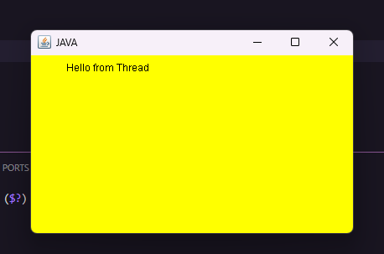

Result
The program successfully creates a Frame titled "JAVA", sets the background color to yellow, uses a thread to continuously refresh the frame, and displays the string at position (50, 50).

- Pizza Cafe Software has provided the following Pizza Order Form for the customer. The rate of Regular Pizza is Rs. 60 and of Pan Pizza Rs. 80.
Ex : 10
27/02/2026
SET-9 Java swings
  - Write the code to clear all the check boxes.
  - Write the code to find the cost of toppings (Rs.10 each) selected by customer and then to calculate the Total Cost as follows:-
Amount = (Rate + Cost of Toppings) * Quantity Aim
To develop a Java program for a Pizza Cafe Order Form to:
    - Clear all checkboxes
    - Calculate total cost based on pizza type, toppings, and quantity
Algorithm
- Start the program
- Create GUI with:
  - Pizza type (Regular / Pan)
  - Toppings (Checkboxes)
  - Quantity field
  - Calculate and Clear buttons
- When Calculate button is clicked:
  - Set rate = 0, toppingCost = 0
  - If Regular selected → rate = 60
  - If Pan selected → rate = 80
  - For each selected topping → add 10 to toppingCost
  - Read quantity
  - Compute:
Amount = (rate + toppingCost) × quantity
  - Display total amount
- When Clear button is clicked:

  - Uncheck all checkboxes
  - Clear quantity and result fields
- End the program
Source Code
import javax.swing.*; import java.awt.event.*;
public class PizzaCafe extends JFrame implements ActionListener
{
JTextField t1,t2,t3,t4,t5;
JRadioButton regular,pan;
JCheckBox cheese,capsicum,pepperoni;
JButton calculateBtn,quitBtn;
PizzaCafe()
{
setTitle("PIZZA CAFE"); setSize(500,400); setLayout(null);
JLabel title = new JLabel("PIZZA CAFE"); title.setBounds(200,20,200,30); add(title);
JLabel l1 = new JLabel("Customer Name"); l1.setBounds(30,80,120,25);
add(l1);
t1 = new JTextField();
t1.setBounds(150,80,120,25); add(t1);
JLabel l2 = new JLabel("Pizza Rate"); l2.setBounds(30,110,120,25); add(l2);
t2 = new JTextField(); t2.setBounds(150,110,120,25); add(t2);
JLabel l3 = new JLabel("Quantity"); l3.setBounds(30,140,120,25); add(l3);
t3 = new JTextField(); t3.setBounds(150,140,120,25); add(t3);
JLabel l4 = new JLabel("Cost of Toppings"); l4.setBounds(30,170,120,25);
add(l4);
t4 = new JTextField(); t4.setBounds(150,170,120,25); add(t4);
JLabel l5 = new JLabel("Amount");
l5.setBounds(30,200,120,25); add(l5);
t5 = new JTextField(); t5.setBounds(150,200,120,25);
add(t5);
JPanel pizzaPanel = new JPanel(); pizzaPanel.setLayout(null);
pizzaPanel.setBorder(BorderFactory.createTitledBorder("Select Pizza Type")); pizzaPanel.setBounds(300,80,150,90);
regular = new JRadioButton("Regular"); regular.setBounds(10,20,100,20);
pan = new JRadioButton("Pan"); pan.setBounds(10,45,100,20);
ButtonGroup bg = new ButtonGroup(); bg.add(regular);
bg.add(pan); pizzaPanel.add(regular); pizzaPanel.add(pan); add(pizzaPanel);
JPanel topPanel = new JPanel(); topPanel.setLayout(null);
topPanel.setBorder(BorderFactory.createTitledBorder("Select Toppings")); topPanel.setBounds(300,180,150,120);
cheese = new JCheckBox("Cheese"); cheese.setBounds(10,20,100,20); capsicum = new JCheckBox("Capsicum"); capsicum.setBounds(10,45,100,20); pepperoni = new JCheckBox("Pepperoni"); pepperoni.setBounds(10,70,100,20); topPanel.add(cheese); topPanel.add(capsicum); topPanel.add(pepperoni);
add(topPanel);
calculateBtn = new JButton("CALCULATE"); calculateBtn.setBounds(120,270,120,30); add(calculateBtn);
quitBtn = new JButton("QUIT"); quitBtn.setBounds(260,270,120,30); add(quitBtn); calculateBtn.addActionListener(this); quitBtn.addActionListener(this); setVisible(true);
}
public void actionPerformed(ActionEvent e)
{
if(e.getSource()==calculateBtn)
{
int rate = 0;
int toppings = 0; if(regular.isSelected())
rate = 60; if(pan.isSelected())
rate = 80; t2.setText(String.valueOf(rate)); if(cheese.isSelected())
toppings += 10; if(capsicum.isSelected())
toppings += 15; if(pepperoni.isSelected())
toppings += 20;
t4.setText(String.valueOf(toppings)); int qty = Integer.parseInt(t3.getText()); int amount = (rate * qty) + toppings; t5.setText(String.valueOf(amount));
}
if(e.getSource()==quitBtn)
{
System.exit(0);
}
}
public static void main(String args[])
{
new PizzaCafe();
}
}

Output

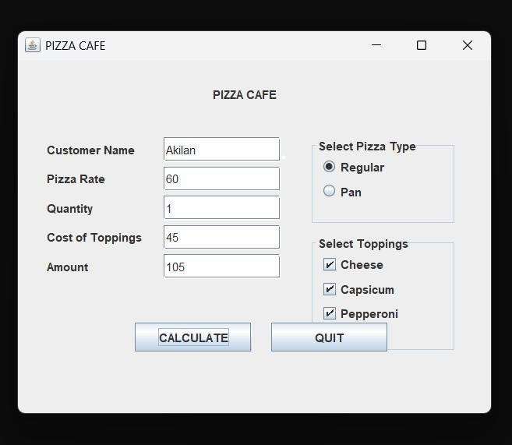
Result
The program successfully clears all checkboxes using setState(false) and calculates the total cost using the formula:
Amount = (Rate + Cost of Toppings) × Quantity

Design and implement a Student Result Management System using Java Swing.
The application should:
- Accept Student Name and Marks of 3 Subjects
- Provide Calculate and Clear buttons
- Compute and display:
  - Total Marks
  - Average Marks
  - Grade (based on average)
- Use appropriate Layout Managers
- Implement proper Event Handling
- Handle invalid inputs using Exception Handling
Aim
To design and implement a Student Result Management System using Java Swing that calculates total, average, and grade with proper event handling and exception handling.
Algorithm
- Start the program
- Create a JFrame with suitable layout (e.g., GridLayout)
- Add components:
  - TextFields for Student Name and 3 Subject Marks
  - Buttons: Calculate and Clear
  - Labels/TextFields for Total, Average, Grade
- When Calculate button is clicked:
  - Read name and marks
  - Convert marks from String to integer
  - If invalid input → handle exception
  - Compute:
    - Total = sum of 3 marks
    - Average = Total / 3
  - Assign Grade:
    - ≥ 90 → A
    - ≥ 75 → B
    - ≥ 50 → C
    - Else → Fail
  - Display results
- When Clear button is clicked:
  - Clear all input and output fields
- End the program Source code
import javax.swing.*; import java.awt.*; import java.awt.event.*;
public class StudentResultSystem extends JFrame implements ActionListener { JTextField nameField, sub1Field, sub2Field, sub3Field;
JLabel totalLabel, avgLabel, gradeLabel; JButton calcBtn, clearBtn; StudentResultSystem() {
setTitle("Student Result Management System"); setSize(400, 420); setDefaultCloseOperation(EXIT_ON_CLOSE); setLocationRelativeTo(null);
setLayout(new GridLayout(9, 2, 10, 10));
// Input Fields
add(new JLabel(" Student Name:")); nameField = new JTextField(); add(nameField);
add(new JLabel(" Subject 1 Marks:")); sub1Field = new JTextField(); add(sub1Field);
add(new JLabel(" Subject 2 Marks:")); sub2Field = new JTextField();
add(sub2Field);
add(new JLabel(" Subject 3 Marks:")); sub3Field = new JTextField(); add(sub3Field);
// Buttons
calcBtn = new JButton("Calculate"); calcBtn.setBackground(new Color(70, 130, 180)); calcBtn.setForeground(Color.WHITE); calcBtn.addActionListener(this);
add(calcBtn);
clearBtn = new JButton("Clear"); clearBtn.setBackground(new Color(220, 80, 80)); clearBtn.setForeground(Color.WHITE); clearBtn.addActionListener(this);
add(clearBtn);
// Result Labels
add(new JLabel(" Total Marks:")); totalLabel = new JLabel("---"); add(totalLabel);
add(new JLabel(" Average Marks:")); avgLabel = new JLabel("---"); add(avgLabel);
add(new JLabel(" Grade:")); gradeLabel = new JLabel("---");
gradeLabel.setFont(new Font("Arial", Font.BOLD, 14)); add(gradeLabel);
setVisible(true);
}
public void actionPerformed(ActionEvent e) {
if (e.getSource() == calcBtn) { try {
String name = nameField.getText().trim(); if (name.isEmpty()) {
JOptionPane.showMessageDialog(this, "Please enter student name!"); return;

100!");
}
double m1 = Double.parseDouble(sub1Field.getText().trim()); double m2 = Double.parseDouble(sub2Field.getText().trim()); double m3 = Double.parseDouble(sub3Field.getText().trim());
if (m1 < 0 || m1 > 100 || m2 < 0 || m2 > 100 || m3 < 0 || m3 > 100) { JOptionPane.showMessageDialog(this, "Marks must be between 0 and
return;

}
double total = m1 + m2 + m3; double avg = total / 3;
String grade;
if (avg >= 90) grade = "O"; else if (avg >= 80) grade = "A+"; else if (avg >= 70) grade = "A"; else if (avg >= 60) grade = "B+"; else if (avg >= 50) grade = "B "; else grade = "F";
totalLabel.setText(String.valueOf(total)); avgLabel.setText(String.format("%.2f", avg)); gradeLabel.setText(grade);
} catch (NumberFormatException ex) {
JOptionPane.showMessageDialog(this, "Please enter valid numeric marks!");
}
} else if (e.getSource() == clearBtn) { nameField.setText(""); sub1Field.setText(""); sub2Field.setText(""); sub3Field.setText(""); totalLabel.setText("---");
avgLabel.setText("---");
gradeLabel.setText("---");
}
}
public static void main(String[] args) { new StudentResultSystem();
}
}

Output
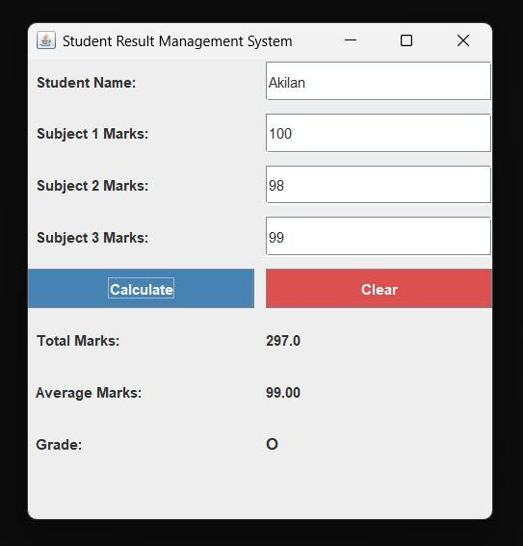
Result
The program successfully uses Java Swing GUI, implements event handling, performs calculations, and handles invalid input using exception handling.

- The given Form Calculates the GCD (HCF) of two Numbers. Write code for the command button (jbutton1) to print the GCD in the jTextField3.

Aim
To write a Java Swing program to calculate the GCD (HCF) of two numbers and display
the result in a text field using a button click. Algorithm
- Start the program
- Enter two numbers in jTextField1 and jTextField2
- Click the Calculate (jButton1) button
- Read both numbers and convert them into integers
- Apply Euclidean Algorithm:
  - While second number ≠ 0
    - temp = second number
    - second = first % second
    - first = temp
- The final value of first number is the GCD
- Display the result in jTextField3
- If input is invalid, display error message
- End the program

Source code
import java.awt.*;
import java.awt.event.*;

class GCDCalculator extends Frame implements ActionListener {
TextField t1, t2, result;
Button btn;

GCDCalculator() {
setTitle("GCD Calculator");
setLayout(null);

Label title = new Label("GCD Calculator", Label.CENTER);
title.setBounds(50, 50, 300, 30);
add(title);

Label l1 = new Label("Number 1:");
l1.setBounds(50, 100, 100, 30);
add(l1);

t1 = new TextField();
t1.setBounds(180, 100, 150, 30);
add(t1);

Label l2 = new Label("Number 2:");
l2.setBounds(50, 150, 100, 30);
add(l2);

t2 = new TextField();
t2.setBounds(180, 150, 150, 30);
add(t2);

Label l3 = new Label("GCD Result:");
l3.setBounds(50, 200, 100, 30);
add(l3);

result = new TextField();
result.setBounds(180, 200, 150, 30);
result.setEditable(false);
result.setBackground(Color.green);
add(result);

btn = new Button("Calculate GCD");
btn.setBounds(130, 250, 150, 30);
add(btn);

btn.addActionListener(this);

setSize(400, 350);
setVisible(true);

addWindowListener(new WindowAdapter() {
public void windowClosing(WindowEvent e) {
dispose();
}
});
}

public void actionPerformed(ActionEvent e) {
int a = Integer.parseInt(t1.getText());
int b = Integer.parseInt(t2.getText());
int gcd = findGCD(a, b);
result.setText(String.valueOf(gcd));
}

int findGCD(int a, int b) {
while (b != 0) {
int temp = b;
b = a % b;
a = temp;
}
return a;
}

public static void main(String[] args) {
new GCDCalculator();
}
}
Output :
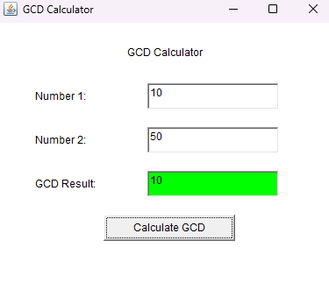
Result
The program successfully calculates and displays the GCD (HCF) of two input numbers in the output text field. It also handles invalid inputs using exception handling.

Ex : 11
27/02/2026
SET-11 Log Report using Threads

Aim :
To develop a Java program that uses multithreading to monitor multiple nodes simultaneously, handle missing log files using a user-defined exception, and generate a final health report after all threads complete execution using join().
Source Code :
class LogFileNotFoundException extends Exception {
LogFileNotFoundException(String msg) {
super(msg);
}
}
class Node extends Thread {
String name;
boolean logExists;
String status = "";

Node(String name, boolean logExists) {
this.name = name;
this.logExists = logExists;
}
public void run() {
try {
System.out.println(name + " scanning...");
Thread.sleep(3000);
if (!logExists) throw new LogFileNotFoundException(name + " log file missing");
status = "Healthy";
System.out.println(name + " completed scan");
} catch (LogFileNotFoundException e) {
status = "Error: " + e.getMessage();
System.out.println(e.getMessage());
} catch (InterruptedException e) {
status = "Interrupted";
}
}
}

public class Main {
public static void main(String[] args) throws Exception {
Node A = new Node("Node A", true);
Node B = new Node("Node B", false);
Node C = new Node("Node C", true);
A.start();
B.start();
C.start();
A.join();
B.join();
C.join();
System.out.println("\nFinal Health Report:");
System.out.println("A: " + A.status);
System.out.println("B: " + B.status);
System.out.println("C: " + C.status);
}
}
Output :
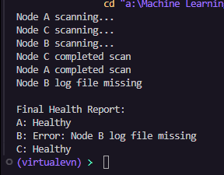
Result :
Thus the above program has been executed successfully using threads .

Ex : 12
27/02/2026
SET-12 Unknown

Aim :
To design and develop a Java Swing-based GUI application using GridBagLayout for a Smart Lab Inventory Logger that captures student details, allows equipment selection, validates input, and logs timestamped entries dynamically.
Source Code :
import javax.swing.*;
import java.awt.*;
import java.awt.event.*;
import java.time.LocalDateTime;
public class Main extends JFrame implements ActionListener {
JTextField nameField, rollField, idField;
JComboBox<String> equipmentBox, categoryBox;
JTextArea logArea;
JButton submitBtn, logBtn;
public Main() {
setTitle("Smart Lab Inventory Logger");
setSize(600, 500);
setLayout(new GridBagLayout());
GridBagConstraints gbc = new GridBagConstraints();
gbc.insets = new Insets(5,5,5,5);
gbc.fill = GridBagConstraints.HORIZONTAL;
JLabel header = new JLabel("Smart Lab Inventory Logger", JLabel.CENTER);
header.setFont(new Font("Arial", Font.BOLD, 18));
gbc.gridx = 0; gbc.gridy = 0; gbc.gridwidth = 2;
add(header, gbc);
gbc.gridwidth = 1;
gbc.gridx = 0; gbc.gridy = 1;
add(new JLabel("Name:"), gbc);
gbc.gridx = 1;
nameField = new JTextField();
add(nameField, gbc);

gbc.gridx = 0; gbc.gridy = 2;
add(new JLabel("Roll Number:"), gbc);
gbc.gridx = 1;
rollField = new JTextField();
add(rollField, gbc);
gbc.gridx = 0; gbc.gridy = 3;
add(new JLabel("Unique ID:"), gbc);
gbc.gridx = 1;
idField = new JTextField();
add(idField, gbc);
gbc.gridx = 0; gbc.gridy = 4;
add(new JLabel("Equipment:"), gbc);
gbc.gridx = 1;
equipmentBox = new JComboBox<>(new String[]{"Oscilloscope","Multimeter","IoT Kit"});
add(equipmentBox, gbc);
gbc.gridx = 0; gbc.gridy = 5;
add(new JLabel("Category:"), gbc);
gbc.gridx = 1;
categoryBox = new JComboBox<>(new String[]{"Microcontrollers","Sensors","Actuators"});
add(categoryBox, gbc);
gbc.gridx = 0; gbc.gridy = 6;
submitBtn = new JButton("Submit");
add(submitBtn, gbc);
gbc.gridx = 1;
logBtn = new JButton("Log Entry");
add(logBtn, gbc);
gbc.gridx = 0; gbc.gridy = 7; gbc.gridwidth = 2;
logArea = new JTextArea(8, 30);
logArea.setEditable(false);
add(new JScrollPane(logArea), gbc);
submitBtn.addActionListener(this);
logBtn.addActionListener(this);
setVisible(true);
setDefaultCloseOperation(JFrame.EXIT_ON_CLOSE);
}

public void actionPerformed(ActionEvent e) {
String name = nameField.getText();
String roll = rollField.getText();
String id = idField.getText();
if (name.isEmpty() || roll.isEmpty() || id.isEmpty()) {
JOptionPane.showMessageDialog(this, "All fields required");
return;
}
if (e.getSource() == submitBtn) {
JOptionPane.showMessageDialog(this, "Submitted Successfully");
}
if (e.getSource() == logBtn) {
String log = LocalDateTime.now() + " | " + name + " | " + roll + " | " + id + " | " +
equipmentBox.getSelectedItem() + " | " + categoryBox.getSelectedItem();
logArea.append(log + "\n");
}
}
public static void main(String[] args) {
new Main();
}
}
Output :
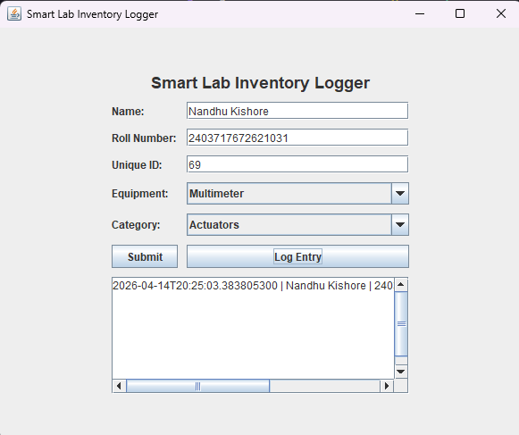
Result :
Thus the program has been executed successfully using java swings.

